**A**

***PROJECT REPORT***

*on*

***TEAM ANALYSIS : Car Data set Analysis***

*Submitted in partial fulfillment of the requirements for the degree of*

**BACHELOR OF TECHNOLOGY**



Session: - 2024

Submitted by

Manvi Paliwal (20ETCCS071)

Khushi Vyas(20ETCCS064)

Bhavesh Dharwar (20ETCCS082)

Under Guidance of

Mr. Aaditya Maheshwari

Assistant Professor

Dept. of CSE TINJRIT, Udaipur

**DEPARTMENT OF COMPUTER SCIENCE AND ENGINEERING**

**TECHNO INDIA NJR INSTITUTE OF TECHNOLOGY, UDAIPUR-313001**

**2024**

**A**

***PROJECT REPORT***

*On*

**TEAM ANALYSIS : Car Data set Analysis**

*Submitted in partial fulfillment of the requirements for the degree of*

**BACHELOR OF TECHNOLOGY**



**Session: - 2024**

Submitted by

Manvi Paliwal (20ETCCS071)

Khushi vyas(20ETCCS064)

Bhavesh Dharwar (20ETCCS018)

8th Sem (CSE)

Under Guidance of

Mr. Aaditya Maheshwari

Assistant Professor

Dept. of CSE TINJRIT, Udaipur

**DEPARTMENT OF COMPUTER SCIENCE AND ENGINEERING**

**TECHNO INDIA NJR INSTITUTE OF TECHNOLOGY, UDAIPUR-313001**

**2024**



Department of Computer Science and Engineering

Techno India NJR Institute of Technology, Udaipur-313001

**Certificate**

This is to certify that project work titled **TEAM ANALYSIS** by **Manvi Paliwal** was successfully carried out in the Department of Computer Science and Engineering, TINJRIT and the report is approved for submission in the partial fulfillment of the requirements for award of degree of Bachelor of Technology in Computer Science and Engineering.

Mr. Aaditya Maheshwari Dr. Rimpy Bishnoi

Assistant Professor Head of Department

Dept. of CSE TINJRIT, Udaipur Dept. of CSE TINJRIT, Udaipur

Date Date



Department of Computer Science and Engineering

Techno India NJR Institute of Technology, Udaipur-313001

**Certificate**

This is to certify that project work titled **TEAM ANALYSIS** by **Khushi Vyas** was successfully carried out in the Department of Computer Science and Engineering, TINJRIT and the report is approved for submission in the partial fulfillment of the requirements for award of degree of Bachelor of Technology in Computer Science and Engineering.

Mr. Aaditya Maheshwari Dr. Rimpy Bishnoi

Assistant Professor Head of Department

Dept. of CSE TINJRIT, Udaipur Dept. of CSE TINJRIT, Udaipur

Date Date



Department of Computer Science and Engineering

Techno India NJR Institute of Technology, Udaipur-313001

**Certificate**

This is to certify that project work titled **TEAM ANALYSIS** by **Bhavesh Dharwar** was successfully carried out in the Department of Computer Science and Engineering, TINJRIT and the report is approved for submission in the partial fulfillment of the requirements for award of degree of Bachelor of Technology in Computer Science and Engineering.

Mr. Aaditya Maheshwari Dr. Rimpy Bishnoi

Assistant Professor Head of Department

Dept. of CSE TINJRIT, Udaipur Dept. of CSE TINJRIT, Udaipur

Date Date

**Examiner Certificate**

This is to certify that the following student

**Manvi Paliwal, Khushi Vyas, Bhavesh Dharwar** of final year B.Tech. (Computer Science and Engineering), was examined for the project work titled

***Team Analysis : Car Data set Analysis***

during the academic year 2023 – 2024 at Techno India NJR Institute of Technology, Udaipur

**Remarks:**

**Date:**

Signature Signature

(**Internal Examiner**) (**External Examiner**)

Name :- Name :-

Designation:- Designation:-

Department: - Department: -

Organization:- Organization:-

**ACKNOWLEDGMENT**

We take this opportunity to record our sincere thanks to all who helped us to successfully complete this work. Firstly, We are grateful to our **supervisor Mr. Aaditya Maheshwari.**

for his invaluable guidance and constant encouragement, support and most importantly for giving us the opportunity to carry out this work.

We would like to express our deepest sense of gratitude and humble regards to our

**Head of Department Dr. Rimpy Bishnoi** for giving invariable encouragement in our endeavors and providing necessary facility for the same. Also, a sincere thanks to all faculty members of CSE, TINJRIT for their help in the project directly or indirectly.

Finally, we would like to thank my friends for their support and discussions that have proved very valuable for us. We are indebted to our parents for providing constant support, love and encouragement. We thank them for the sacrifices they made so that we could grow up in a learning environment. They have always stood by us in everything we have done, providing constant support, encouragement and love

**Manvi Paliwal (20ETCSS071)**

**Khushi Vyas (20ETCCS064)**

**Bhavesh Dharwar (20ETCCS018)**

DEPARTMENT OF COMPUTER SCIENCE AND ENGINEERING

TECHNO INDIA NJR INSTITUTE OF TECHNOLOGY, UDAIPUR-313001

**CONTENTS**

|  |  |
| --- | --- |
| **Name of Contents** | **Page no.** |
| Certificate 1 | 3-8 |
| Certificate 2 | 9 |
| Acknowledgements | 10 |
| Contents | 11 |
| List of Figures | 12 |
| Chapter 1: Introduction   * 1. Title of Project   2. Objective of the Project   3. Technology Used   4. Technology Advantages and Disadvantages | 13  13  14  15  16 |
| Chapter 2: Implementation  2.1 Step 1: Data collection & cleaning, Processing  2.2 Step 2: Exploratory Data Analysis  2.3 Step 3: Feature Engineering   * 1. Step 4: Model Development & Interpretation   2. Step 5: Reporting & Communication   3. Step 6: Deployement & Integration | 17  17  20  22  23  24  25  27  30 |
| Conclusion | 36 |
| Future Scope | 38 |
| Bibliography | 40 |

**CHAPTER 1: INTRODUCTION**

**Name of the project:**

Car Data Set Analysis: Team Analysis

**Problem Statement:**

The automotive industry is characterized by a vast array of car models, each with unique specifications, features, and performance metrics. With the increasing complexity of consumer preferences, environmental considerations, and technological advancements, there is a need for a comprehensive analysis of a diverse car dataset. The problem at hand is to extract meaningful insights from this dataset, addressing key challenges and questions in the automotive domain. The specific issues that this project aims to tackle include:

**Objective of project:**

**The aim of this project is to leverage data analysis techniques to gain actionable insights into the automotive industry using a comprehensive car dataset.**.

*Objective:*

The objective is to extract valuable insights related to market trends, consumer preferences, performance evaluation, predictive modeling, customer segmentation, quality assurance, environmental impact, supply chain optimization, safety analysis, and more.

*Scope:*

This project encompasses various aspects of the automotive industry, including but not limited to sales data, pricing trends, fuel efficiency, safety ratings, warranty claims, environmental impact assessments, supply chain efficiency, and accident analysis. The analysis will involve data collection, preprocessing, exploratory data analysis, statistical modeling, and visualization techniques to provide stakeholders with actionable insights for informed decision-making.

**Technology Stack:**

**Python: Widely used for data analysis and machine learning tasks due to its extensive libraries such as Pandas, NumPy, SciPy, Scikit-learn, Matplotlib, and Seaborn.**

**R: Another popular language for statistical analysis and data visualization, with packages like ggplot2, dplyr, and tidyr.**

**Data Analysis Tools:**

**Jupyter Notebooks: Interactive computing environments that support code execution, visualization, and documentation, making them ideal for exploratory data analysis.**

**RStudio: Integrated development environment (IDE) specifically designed for R programming.**

**Machine Learning Libraries:**

**Scikit-learn: A comprehensive library for classical machine learning algorithms such as regression, classification, clustering, and dimensionality reduction.**

**TensorFlow and PyTorch: Deep learning frameworks for building and training neural networks for tasks like image recognition, natural language processing, and time series analysis.**

**Data Visualization Tools:**

**Matplotlib and Seaborn: Python libraries for creating static, interactive, and publication-quality visualizations.**

**Plotly and Bokeh: Libraries for creating interactive and web-based visualizations.**

**ggplot2: R package for producing elegant and customizable plots based on the grammar of graphics.**

**Database Technologies:**

**SQL: For querying and managing relational databases where car data may be stored.**

**NoSQL databases (e.g., MongoDB): Useful for handling unstructured or semi-structured car data, such as customer reviews or sensor data.**

**Big Data Technologies:**

**Apache Spark: Framework for distributed data processing and analysis, suitable for handling large-scale datasets.**

**Hadoop: Distributed storage and processing framework for big data analytics.**

**Cloud Computing Platforms:**

**Amazon Web Services (AWS), Google Cloud Platform (GCP), Microsoft Azure: Offer cloud-based services for data storage, computation, and analysis, along with specialized tools for machine learning and big data processing.**

**Geospatial Analysis Tools:**

**GeoPandas: Extends the Pandas library to support geospatial data analysis.**

**QGIS and ArcGIS: Desktop GIS software for visualizing and analyzing spatial data related to car locations, traffic patterns, and infrastructure.**

**Natural Language Processing (NLP) Tools:**

**NLTK (Natural Language Toolkit) and spaCy: Python libraries for processing and analyzing textual data, useful for sentiment analysis of customer reviews or analyzing unstructured data.**

**Web Scraping Tools:**

**Beautiful Soup and Scrapy: Python libraries for extracting data from websites, useful for collecting online car listings, reviews, or pricing information.**

**Advantages of Tech Stack:**

Versatile with extensive libraries for data analysis, ML, and visualization.

Large and active community support.

Easy to learn and integrate with other languages.

Scalable for handling large datasets and complex tasks.

**Disadvantages of Tech Stack:**

Performance may be slower for CPU-intensive tasks.

Global Interpreter Lock can limit concurrency.

Memory management may lead to inefficiency.

Deployment complexity with managing dependencies.

**CHAPTER 2: IMPLIMENTATION**

**Step 1:**

**Data Collection &  
Data Cleaning and Processing**

In a car dataset analysis project, data collection involves sourcing diverse datasets to comprehensively analyze various aspects of the automotive industry. This typically includes acquiring public datasets from repositories like Kaggle or government databases, accessing APIs provided by manufacturers and review websites, and employing web scraping techniques to gather information from dealer websites and automotive forums. Additionally, integration with internal databases may be necessary to incorporate proprietary sales and customer data. Throughout this process, ensuring data quality through validation checks and documentation is paramount for generating reliable insights. By leveraging these diverse data sources, the analysis can provide a holistic understanding of market trends, consumer preferences, and performance metrics within the automotive sector.

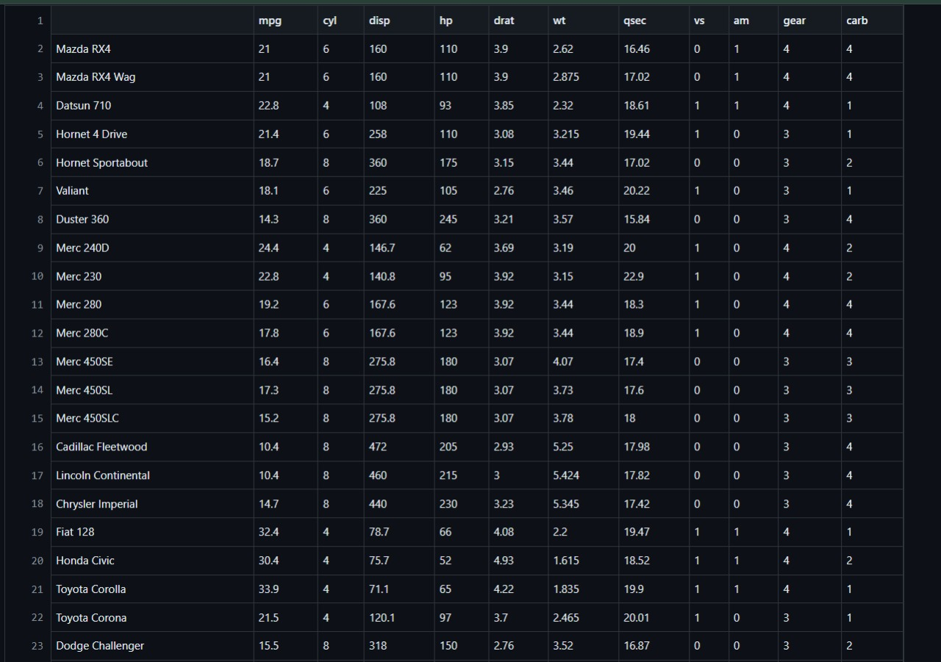

**Step 2:**

**Exploratory Data Analysis(EDA)**

In a car dataset analysis project, exploratory data analysis (EDA) is crucial for gaining insights into the dataset's characteristics and identifying patterns. EDA involves performing summary statistics, visualizations, and correlation analyses to understand variables' distributions, relationships, and potential outliers. For instance, histograms and scatter plots can reveal distributions and correlations between car features like price, mileage, and horsepower. Box plots and bar charts can highlight differences between car brands or categories. Additionally, techniques like dimensionality reduction or clustering can help uncover hidden structures within the data. EDA provides a foundation for subsequent modeling and hypothesis testing, guiding further analysis and decision-making in the automotive industry.

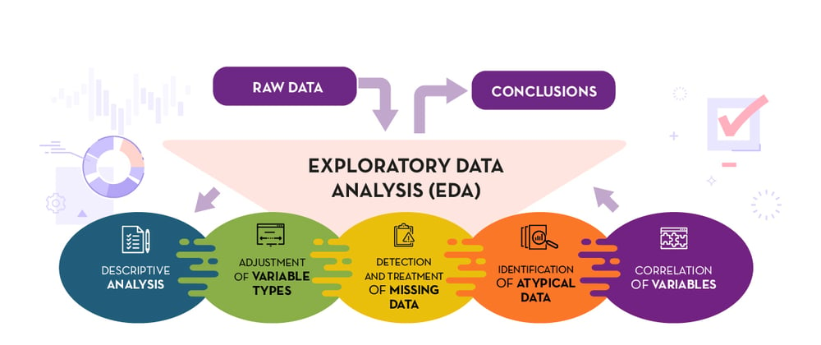

**Step 3 :**

**Feature Engineering**

Feature Creation: Generating new features based on existing data. For example, creating a "age_of_vehicle" feature by subtracting the manufacturing year from the current year.

Feature Scaling: Standardizing numerical features to a similar scale to prevent biases in model training. Techniques like Min-Max scaling or standardization (z-score normalization) can be applied.

Handling Categorical Variables: Encoding categorical variables into numerical representations suitable for modeling. This may involve techniques like one-hot encoding or label encoding.

Handling Missing Values: Addressing missing data by imputing values or creating binary indicator variables to denote missingness.

Interaction Features: Creating interaction terms by combining two or more features to capture synergistic effects. For instance, multiplying "engine_size" and "horsepower" to represent engine power.

Dimensionality Reduction: Employing techniques like PCA (Principal Component Analysis) or LDA (Linear Discriminant Analysis) to reduce the dimensionality of the feature space while preserving relevant information.

Feature Selection: Identifying the most relevant features for model prediction to improve model performance and reduce overfitting. This can be achieved through statistical tests, feature importance rankings, or automated feature selection algorithms.

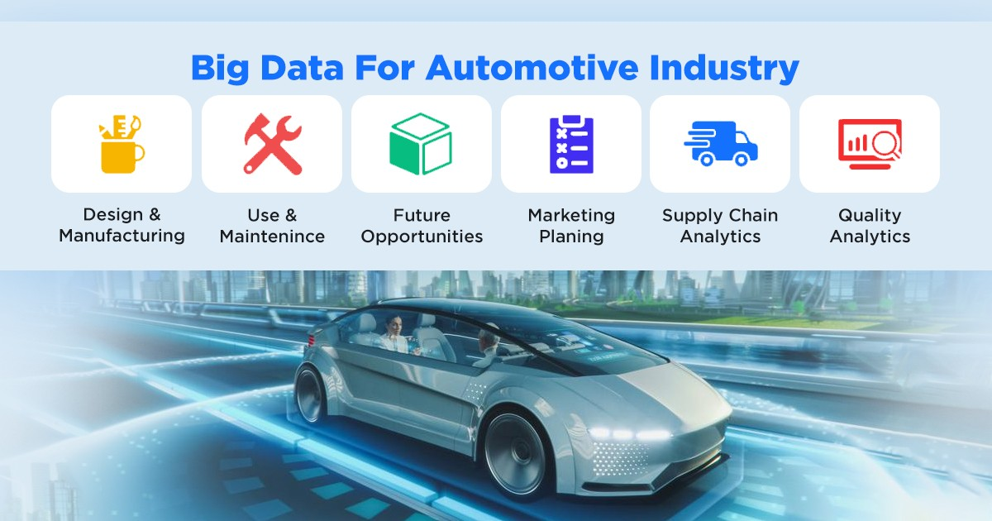

**Step 4:**

**Model Development &   
Model Interpretation**

Data Preparation:

Split the dataset into training, validation, and testing sets to evaluate model performance.

Prepare the features (independent variables) and target variable (dependent variable) for modeling.

Model Selection:

Choose suitable machine learning algorithms based on the nature of the analysis (e.g., regression for price prediction, classification for customer segmentation).

Consider factors such as algorithm complexity, interpretability, and performance metrics.

Model Training:

Train the selected models using the training dataset.

Utilize techniques like cross-validation to assess model generalization and optimize hyperparameters.

Model Evaluation:

Evaluate model performance using the validation dataset.

Use appropriate evaluation metrics (e.g., mean squared error for regression, accuracy for classification) to assess model accuracy and reliability.

Model Optimization:

Fine-tune model hyperparameters to improve performance.

Explore techniques like regularization, ensemble methods, or feature selection to enhance model effectiveness.

Model Interpretation:

Interpret the trained models to understand the factors influencing predictions.

Analyze feature importance, partial dependence plots, or SHAP (SHapley Additive exPlanations) values to gain insights into variable relationships.

Model Validation:

Validate the trained models using the testing dataset to assess real-world performance.

Compare model predictions against actual outcomes to ensure reliability and generalization.

Iterative Improvement:

Iterate on model development based on feedback from stakeholders or additional insights gained during the process.

Refine the models, explore alternative algorithms, or incorporate new features to improve predictive accuracy and usefulness.

**Step 5 :**

**Reporting & communication**

In a car dataset analysis project, effective reporting and communication are pivotal for translating insights into actionable decisions. This involves summarizing key findings, visualizing results through charts and graphs, and providing a narrative explanation of the analysis methodology and interpretation. Recommendations are offered based on the analysis, along with a discussion of any limitations or uncertainties. Optionally, interactive dashboards can be developed for dynamic exploration of the data. Feedback from stakeholders is solicited for iterative refinement, and thorough documentation ensures the report's clarity and auditability. Ultimately, clear and engaging presentations are delivered to stakeholders to facilitate informed decision-making in the automotive industry.

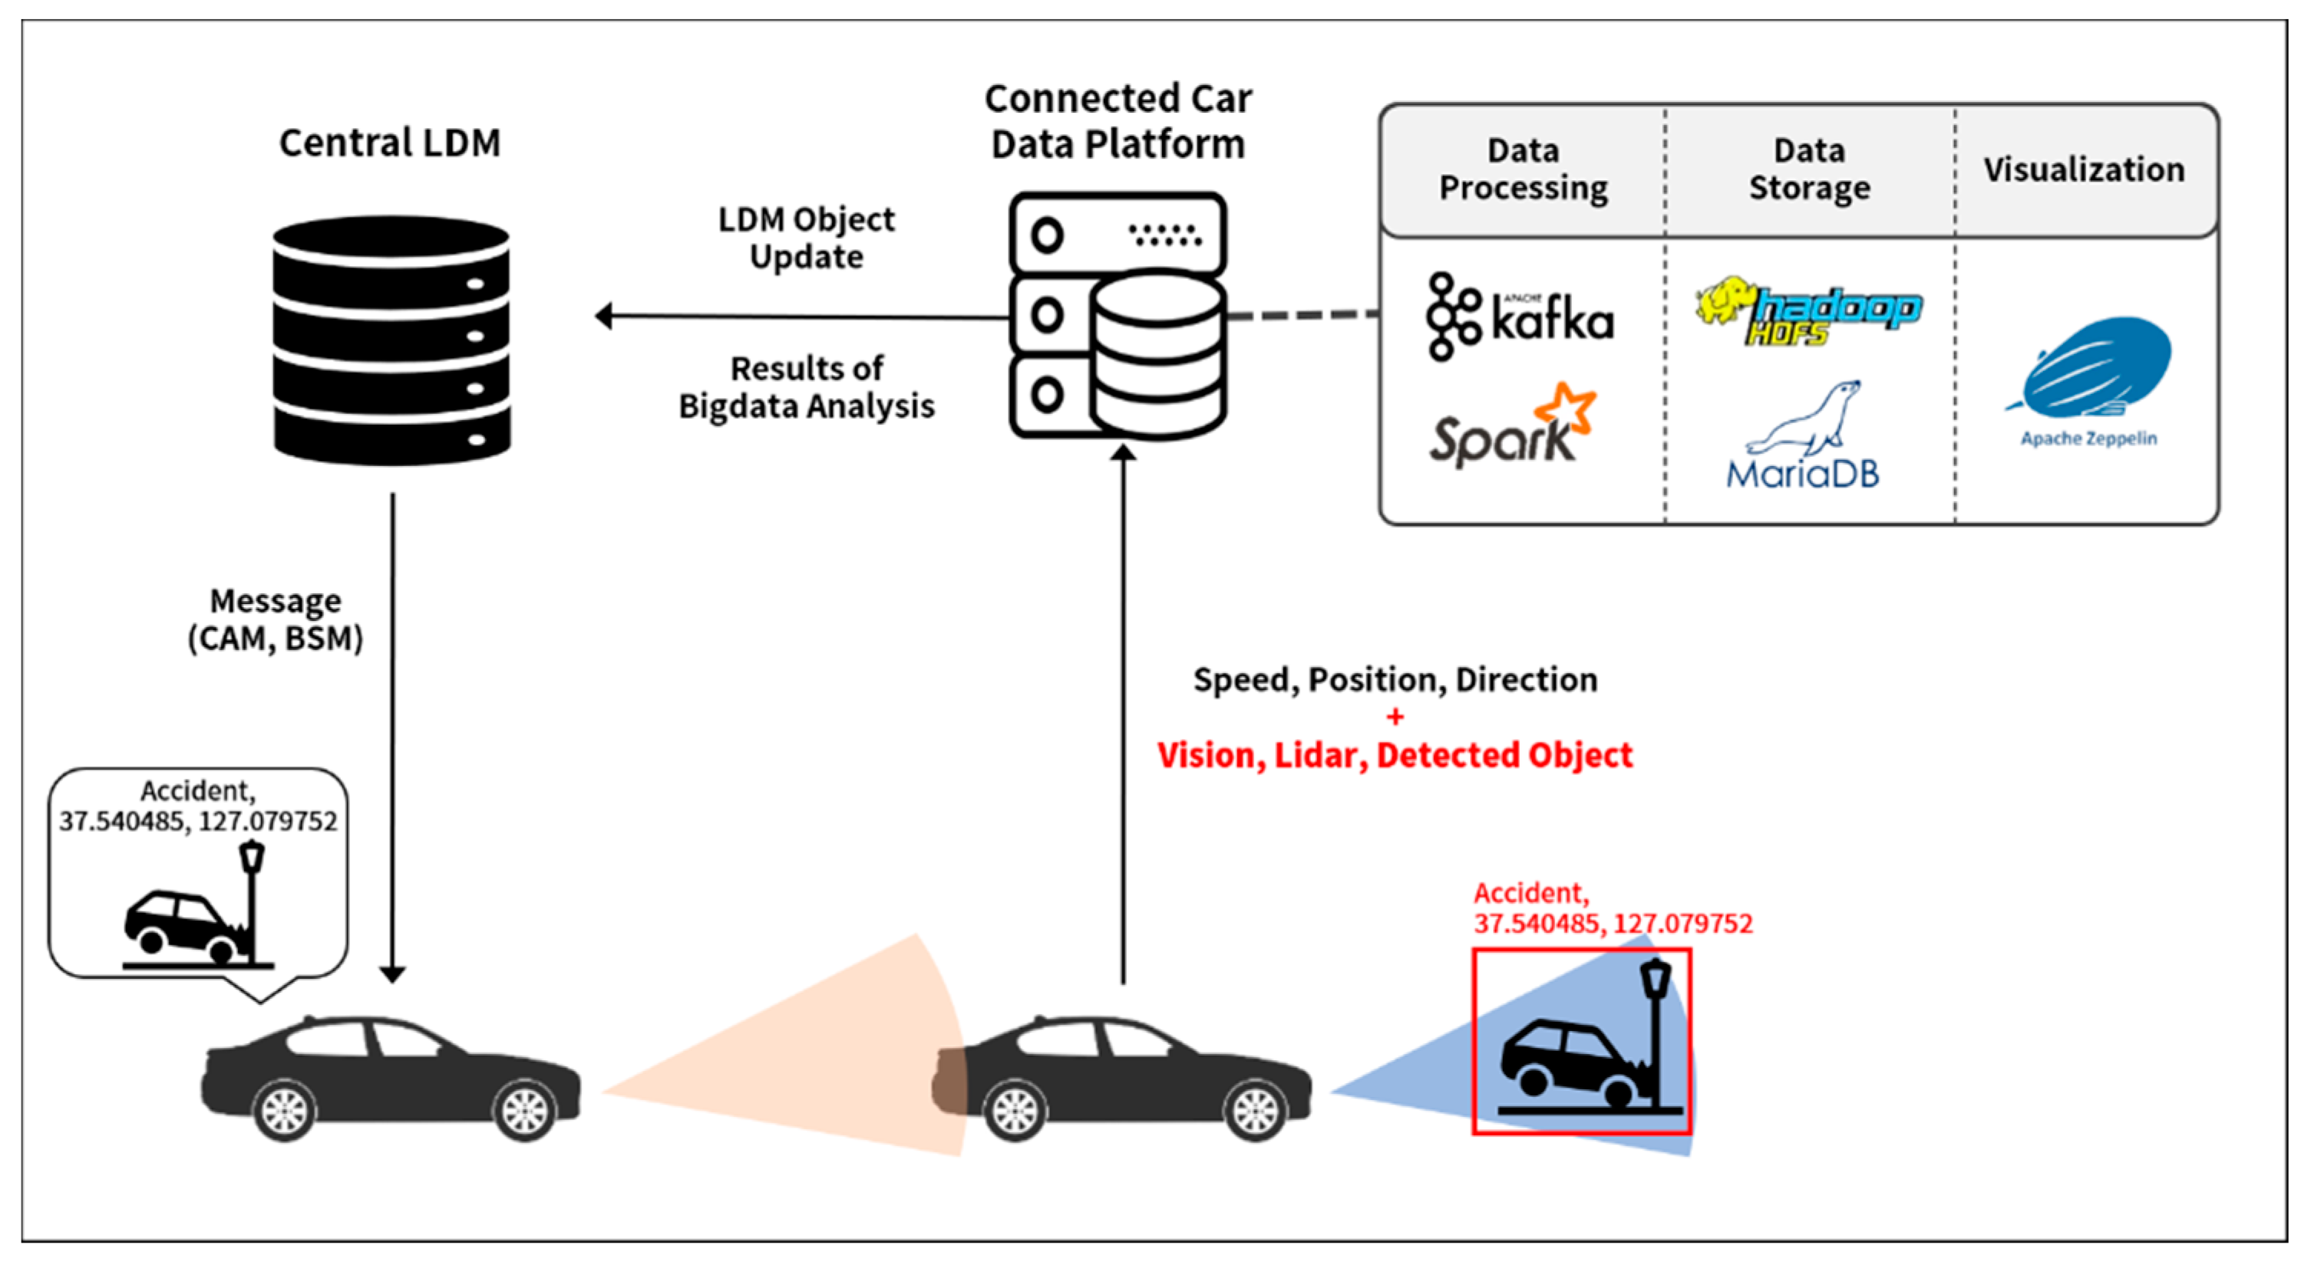

**Step 6 :**

**Deployment & Integration:**

Model Deployment: Deploying predictive models as software applications, web services, or APIs to automate predictions. This allows stakeholders to leverage model insights in real-time decision-making processes, such as pricing optimization, inventory management, or personalized marketing campaigns.

Integration with Business Systems: Integrating analysis results into existing business systems, such as customer relationship management (CRM) or enterprise resource planning (ERP) systems. This enables seamless access to insights within familiar workflows, enhancing decision-making efficiency and effectiveness.

Dashboard Development: Developing interactive dashboards or reporting tools to visualize analysis results and facilitate data-driven decision-making. Dashboards can provide stakeholders with a user-friendly interface for exploring trends, monitoring key performance indicators, and tracking the impact of interventions.

Automation of Data Pipelines: Automating data pipelines for data collection, preprocessing, modeling, and reporting. This streamlines the analysis process, reduces manual effort, and ensures the timely delivery of insights to stakeholders.

Scalability and Maintenance: Ensuring scalability and maintainability of deployed solutions to accommodate growing data volumes and evolving business needs. Regular monitoring and maintenance of deployed systems are essential to ensure continued reliability and relevance.

Training and Support: Providing training and support to stakeholders on using deployed solutions effectively. This includes educating users on interpreting analysis results, navigating dashboards, and leveraging insights to drive decision-making.

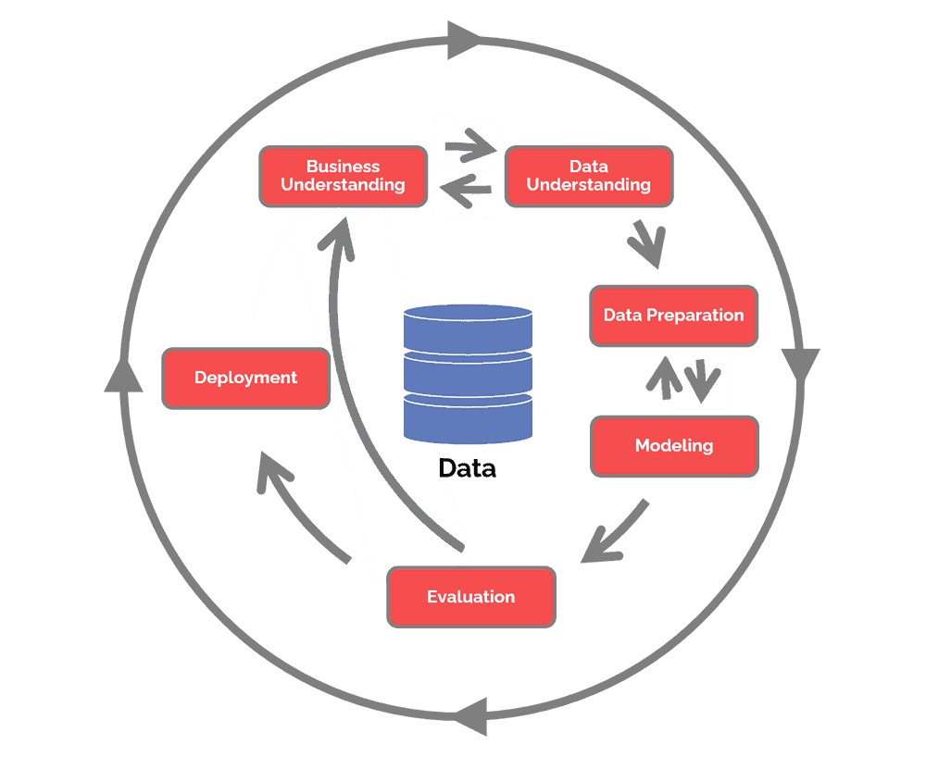

**Conclusion:**

Conclusion: Leveraging Insights from Car Dataset Analysis for Informed Decision-Making in the Automotive Industry

In the ever-evolving landscape of the automotive industry, data analysis has emerged as a critical tool for gaining actionable insights and driving informed decision-making. Through comprehensive car dataset analysis, stakeholders can unlock valuable insights into market trends, consumer preferences, performance metrics, and operational efficiency, ultimately positioning themselves for success in a competitive market environment.

Car dataset analysis offers a multitude of benefits for various stakeholders within the automotive ecosystem. Manufacturers can gain valuable insights into consumer preferences, enabling them to design and produce vehicles that align with market demands. By analyzing sales data, customer reviews, and demographic trends, manufacturers can identify emerging market trends and tailor their product offerings accordingly. Additionally, performance evaluation through data analysis allows manufacturers to benchmark their vehicles against competitors, identify areas for improvement, and optimize product features to enhance competitiveness and customer satisfaction.

For dealerships and retailers, car dataset analysis provides insights into pricing strategies, inventory management, and customer segmentation. By analyzing sales data and market trends, dealerships can optimize pricing strategies to maximize profitability while remaining competitive in the market. Furthermore, customer segmentation analysis enables dealerships to target specific demographic groups with personalized marketing campaigns, enhancing customer engagement and driving sales growth.

In addition to manufacturers and dealerships, car dataset analysis also benefits consumers by empowering them to make informed purchasing decisions. Through comparative analysis of vehicle specifications, safety ratings, and consumer reviews, consumers can evaluate various options and select vehicles that best meet their needs and preferences. Furthermore, predictive modeling techniques can provide insights into future vehicle depreciation rates, helping consumers make informed decisions about long-term ownership costs.

Moreover, car dataset analysis contributes to broader societal benefits by promoting safety, sustainability, and innovation within the automotive industry. By analyzing accident data and safety ratings, policymakers and regulatory agencies can identify trends and implement measures to improve vehicle safety standards, ultimately reducing the incidence of accidents and fatalities on the road. Additionally, environmental impact assessments enable stakeholders to identify opportunities for reducing carbon emissions and promoting sustainable transportation solutions, aligning with global efforts to combat climate change.

As technology continues to advance, the scope and complexity of car dataset analysis are expected to expand, offering new opportunities for innovation and value creation. Emerging technologies such as artificial intelligence, machine learning, and big data analytics hold the potential to revolutionize the automotive industry by enabling predictive maintenance, autonomous driving, and personalized mobility services. By harnessing the power of data analysis, stakeholders can navigate the evolving automotive landscape with confidence, driving innovation, sustainability, and growth.

**Future Scope:**

Future Scope of Car Dataset Analysis: Embracing Innovation and Advancement in the Automotive Industry

As technology continues to evolve at a rapid pace, the future scope of car dataset analysis holds immense potential for driving innovation, enhancing customer experiences, and shaping the future of mobility. Several emerging trends and advancements are poised to revolutionize the automotive industry, paving the way for exciting opportunities in data-driven analysis and decision-making.

One of the most significant trends shaping the future of car dataset analysis is the rise of connected vehicles and the Internet of Things (IoT). With an increasing number of vehicles equipped with sensors and connectivity capabilities, car dataset analysis can leverage real-time data streams to monitor vehicle performance, predict maintenance issues, and optimize driving experiences. By harnessing IoT data, stakeholders can gain deeper insights into vehicle behavior, driver habits, and traffic patterns, enabling more proactive and personalized services.

Furthermore, advancements in artificial intelligence (AI) and machine learning (ML) present exciting opportunities for predictive analytics and autonomous driving. Car dataset analysis powered by AI and ML algorithms can anticipate driver behavior, optimize route planning, and enhance vehicle safety through predictive maintenance and real-time risk assessment. Additionally, autonomous driving technologies rely heavily on data analysis to interpret sensor data, navigate complex environments, and make split-second decisions, ushering in a new era of mobility and transportation.

Another area of future scope in car dataset analysis is the integration of data from diverse sources, including social media, smart cities, and environmental sensors. By aggregating and analyzing data from multiple sources, stakeholders can gain a comprehensive understanding of the broader ecosystem in which vehicles operate, including factors such as weather conditions, traffic congestion, and air quality. This holistic approach enables more informed decision-making and facilitates the development of sustainable, environmentally friendly transportation solutions.

Another area of future scope in car dataset analysis is the integration of data from diverse sources, including social media, smart cities, and environmental sensors. By aggregating and analyzing data from multiple sources, stakeholders can gain a comprehensive understanding of the broader ecosystem in which vehicles operate, including factors such as weather conditions, traffic congestion, and air quality. This holistic approach enables more informed decision-making and facilitates the development of sustainable, environmentally friendly transportation solutions.

**BIBLIOGRAPHY:**

1. Kagle: kaggle.com/code/rhythmbhaumik/car-data-analysis-project
2. UCI Machine Learning Repository : https://archive.ics.uci.edu/dataset/10/automobile
3. Government Databases : github.com/shreyamdg/automobile-data-set-analysis
4. Academic Research Papers: :
5. Industry Reports and Publications :
6. Open Data Portals :